**ÔN THI CUỐI KÌ**

Contents

I. CustomListView 3

1. GUI 3

2. Hiển thị 3

a. activity_main.xml 3

b. custom_row.xml 4

3. Code 5

a. CustomAdapter class 5

b. MainActivity 5

II. ListViewApp 6

1. Demo App 6

2. Hiển thị 6

a. GUI 6

b. Code 7

3. Code 7

III. GridView – Phóng ảnh 8

1. Demo 8

2. activity_main 8

3. Zoom_in.xml 10

4. Code 10

a. MyImgAdapter 10

b. MainActivity 11

IV. Xem them xóa sửa listview. 12

1. Demo App 12

2. Nhánh các thư mục 13

3. Drawable 13

4. Menu 13

a. longtime_onclick.xml 14

b. menu.xml 14

5. String 15

6. Layout 15

a. activity_main.xml 15

b. custom_row.xml 16

c. custom_row_dialog.xml 16

d. dialog_add.xml 17

e. list_imgage.xml 18

7. Picture class 19

8. CustomAapter class. 20

9. Code Main 21

V. MENU 26

1. Demo App 26

2. Thư mục 26

3. Anim 26

4. Drawable 27

5. Menu 27

6. Values 28

7. Layout 28

• GUI 28

• Code 28

8. Code 29

VI. GridView 30

1. DemoApp 30

2. Layout 30

a. String 30

b. GUI 31

c. Code 31

3. Code 32

1. **CustomListView**
2. **GUI**

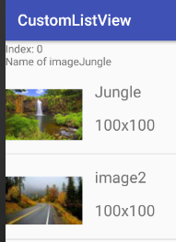 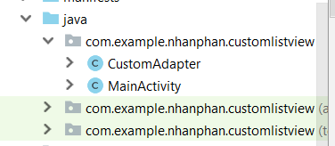 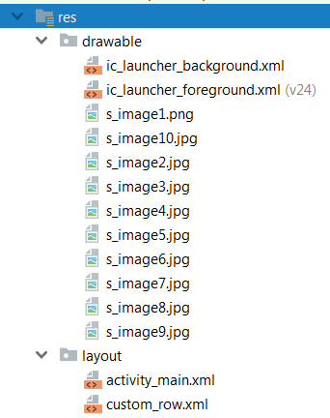

1. **Hiển thị**
2. **activity_main.xml**

* **GUI**

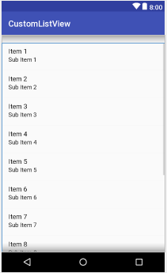 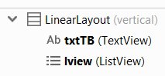

* **Code**

|  |
| --- |
| *<?***xml version="1.0" encoding="utf-8"***?>* <**LinearLayout xmlns:android="http://schemas.android.com/apk/res/android"  xmlns:app="http://schemas.android.com/apk/res-auto"  xmlns:tools="http://schemas.android.com/tools"  android:layout_width="match_parent"  android:layout_height="match_parent"  android:orientation="vertical"  tools:context=".MainActivity"  tools:layout_editor_absoluteY="81dp"**>  <**TextView  android:id="@+id/txtTB"  android:layout_width="wrap_content"  android:layout_height="wrap_content"  android:text=""  tools:layout_editor_absoluteX="154dp"  tools:layout_editor_absoluteY="246dp"** />  <**ListView  android:id="@+id/lview"  android:layout_width="match_parent"  android:layout_height="match_parent"** /> </**LinearLayout**> |

1. **custom_row.xml**

* **GUI**

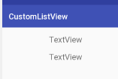 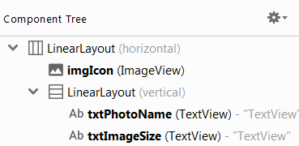

* **Code**

|  |
| --- |
| *<?***xml version="1.0" encoding="utf-8"***?>* <**LinearLayout  xmlns:android="http://schemas.android.com/apk/res/android" android:layout_width="match_parent"  android:layout_height="match_parent"  android:orientation="horizontal"**>  <**ImageView  android:layout_marginTop="10dp"  android:layout_width="100dp"  android:layout_height="100dp"  android:id="@+id/imgIcon"**/>  <**LinearLayout  android:layout_width="wrap_content"  android:layout_height="wrap_content"  android:layout_margin="16dp"  android:orientation="vertical"**>  <**TextView  android:id="@+id/txtPhotoName"  android:layout_width="wrap_content"  android:layout_height="wrap_content"  android:layout_weight="1"  android:textSize="20dp"  android:layout_marginBottom="16dp"  android:text="TextView"** />   <**TextView  android:id="@+id/txtImageSize"  android:layout_width="wrap_content"  android:layout_height="wrap_content"  android:layout_weight="1"  android:textSize="20dp"  android:text="TextView"** />  </**LinearLayout**> </**LinearLayout**> |

1. **Code**
2. **CustomAdapter class**

|  |
| --- |
| **package** com.example.nhanphan.customlistview;  **import** android.app.Activity; **import** android.content.Context; **import** android.support.annotation.NonNull; **import** android.support.annotation.Nullable; **import** android.view.LayoutInflater; **import** android.view.View; **import** android.view.ViewGroup; **import** android.widget.ArrayAdapter; **import** android.widget.CursorAdapter; **import** android.widget.ImageView; **import** android.widget.TextView;  **import** java.util.zip.Inflater;  **public class** CustomAdapter **extends** ArrayAdapter<String> {  Context **context**;  Integer[] **thumnails**;  String [] **imageNames**;  **public** CustomAdapter(Context context, **int** Layout, String [] imageNames, Integer[] thumnails){  **super**(context,R.layout.***custom_row***,imageNames);  **this**.**context** = context;  **this**.**thumnails** = thumnails;  **this**.**imageNames** = imageNames;  }  @NonNull  @Override  **public** View getView(**int** position, @Nullable View convertView, @NonNull ViewGroup parent) {  *//return super.getView(position, convertView, parent);* LayoutInflater inflater = ((Activity)**context**).getLayoutInflater();  View row = inflater.inflate(R.layout.***custom_row***, **null**);   ImageView imgIcon = (ImageView)row.findViewById(R.id.***imgIcon***);  TextView txtPhotoName = (TextView)row.findViewById(R.id.***txtPhotoName***);  TextView txtImageSize = (TextView)row.findViewById(R.id.***txtImageSize***);   imgIcon.setImageResource(**thumnails**[position]);  txtPhotoName.setText(**imageNames**[position]);  txtImageSize.setText(**"100x100"**);   **return** (row);  } } |

1. **MainActivity**

|  |
| --- |
| **package** com.example.nhanphan.customlistview; **import** android.support.v7.app.AppCompatActivity; **import** android.os.Bundle; **import** android.view.View; **import** android.widget.AdapterView; **import** android.widget.CursorAdapter; **import** android.widget.ListView; **import** android.widget.TextView;  **public class** MainActivity **extends** AppCompatActivity {  String **imageNames**[] = {**"Jungle"**,**"image2"**,**"image3"**,**"image4"**,**"image5"**,**"image6"**,**"image7"**,**"image8"** ,**"image9"**,**"image10"**,};  Integer **thumbnails**[] = {R.drawable.***s_image1***,R.drawable.***s_image2***, R.drawable.***s_image3***, R.drawable.***s_image4***,R.drawable.***s_image5***,R.drawable.***s_image6***,R.drawable.***s_image7***,R.drawable.***s_image8***,R.drawable.***s_image9***,R.drawable.***s_image10***};   ListView **lv**;  TextView **txttb**;  @Override  **protected void** onCreate(Bundle savedInstanceState) {  **super**.onCreate(savedInstanceState);  setContentView(R.layout.***activity_main***);   **lv** = (ListView) findViewById(R.id.***lview***);  **txttb** = (TextView) findViewById(R.id.***txtTB***);   CustomAdapter adapter = **new** CustomAdapter(**this**, R.layout.***custom_row***, **imageNames**, **thumbnails**);  **lv**.setAdapter(adapter);   **lv**.setOnItemClickListener(**new** AdapterView.OnItemClickListener() {  @Override  **public void** onItemClick(AdapterView<?> parent, View view, **int** position, **long** id) {  String selectedItem = **"Index: "** + position + **"\nName of image"** + **imageNames**[position];  **txttb**.setText(selectedItem);  }  });  } } |

1. **ListViewApp**
2. **Demo App**

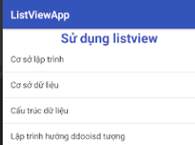 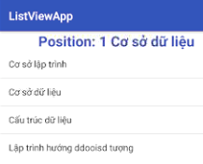

1. **Hiển thị**
2. **GUI**

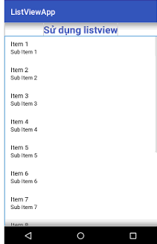 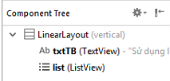

1. **Code**

|  |
| --- |
| *<?***xml version="1.0" encoding="utf-8"***?>* <**LinearLayout xmlns:android="http://schemas.android.com/apk/res/android"  xmlns:app="http://schemas.android.com/apk/res-auto"  xmlns:tools="http://schemas.android.com/tools"  android:layout_width="match_parent"  android:layout_height="wrap_content"  android:orientation="vertical"  tools:context=".MainActivity"**>  <**TextView  android:id="@+id/txtTB"  android:layout_width="wrap_content"  android:layout_height="wrap_content"  android:textSize="25dp"  android:textStyle="bold"  android:textColor="@color/colorPrimary"  android:layout_gravity="center"  android:text="Sử dụng listview"**/>  <**ListView  android:id="@+id/list"  android:layout_width="match_parent"  android:layout_height="match_parent"**>  </**ListView**> </**LinearLayout**> |

1. **Code**

|  |
| --- |
| **package** vn.edu.nhanphan.listviewapp;  **import** android.app.ListActivity; **import** android.support.v7.app.AppCompatActivity; **import** android.os.Bundle; **import** android.view.View; **import** android.widget.AdapterView; **import** android.widget.ArrayAdapter; **import** android.widget.ListView; **import** android.widget.TextView;  **import** java.lang.reflect.Array; *//Xây dựng ListView kế thừa tư ListActivity* **public class** MainActivity **extends** AppCompatActivity {   TextView **txtMSg**, **txtEmpty**;  ListView **listView**;  String[] **items** = {**"Cơ sở lập trình"**, **"Cơ sở dữ liệu"**,**"Cấu trúc dữ liệu"**,**"Lập trình hướng ddooisd tượng"**};  @Override  **protected void** onCreate(Bundle savedInstanceState) {  **super**.onCreate(savedInstanceState);  setContentView(R.layout.***activity_main***);  **txtMSg** = (TextView) findViewById(R.id.***txtTB***);  **listView** = (ListView) findViewById(R.id.***list***);  **listView**.setAdapter(**new** ArrayAdapter<String>(**this**, android.R.layout.***simple_list_item_1***, **items**));  *//setListAdapter(new ArrayAdapter<>(this, android.R.layout.simple_list_item_1,items));  //apter(new ArrayAdapter<String>(this, android.R.layout.simple_list_item_1, items));* **listView**.setOnItemClickListener(**new** AdapterView.OnItemClickListener() {  @Override  **public void** onItemClick(AdapterView<?> parent, View view, **int** position, **long** id) {  **txtMSg**.setText(**"Position: "**+position + **" "**+**items**[position]);  }  });  } } |

1. **GridView – Phóng ảnh**
2. **Demo**

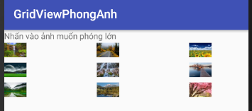 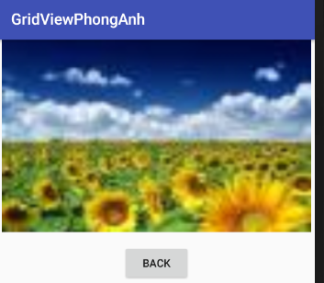

1. **activity_main**
2. **Layout**

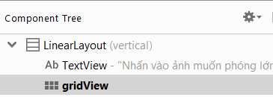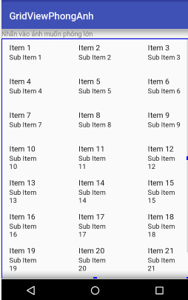 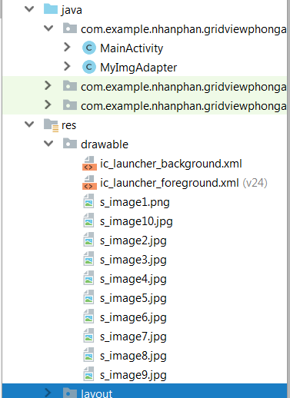

1. **Code**

|  |
| --- |
| *<?***xml version="1.0" encoding="utf-8"***?>* <**LinearLayout xmlns:android="http://schemas.android.com/apk/res/android"  xmlns:app="http://schemas.android.com/apk/res-auto"  xmlns:tools="http://schemas.android.com/tools"  android:layout_width="match_parent"  android:layout_height="match_parent"  android:orientation="vertical"  tools:context=".MainActivity"**>  <**TextView  android:layout_width="match_parent"  android:layout_height="wrap_content"  android:text="Nhấn vào ảnh muốn phóng lớn"** />  <**GridView  android:id="@+id/gridView"  android:layout_width="match_parent"  android:layout_height="match_parent"  android:addStatesFromChildren="true"  android:columnWidth="100dip"  android:stretchMode="spacingWidth"  android:verticalSpacing="5dip"  android:horizontalSpacing="5dip"  android:numColumns="auto_fit"** /> </**LinearLayout**> |

1. **Zoom_in.xml**
2. **GUI**

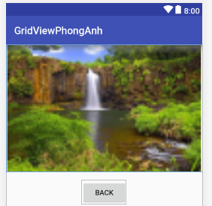 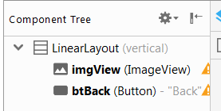

1. **Code**

|  |
| --- |
| *<?***xml version="1.0" encoding="utf-8"***?>* <**LinearLayout  xmlns:android="http://schemas.android.com/apk/res/android"  xmlns:apps="http://schemas.android.com/apk/res-auto"  android:layout_width="match_parent"  android:layout_height="match_parent"  android:orientation="vertical"**>  <**ImageView  android:id="@+id/imgView"  android:layout_width="match_parent"  android:layout_height="250dp"  apps:srcCompat="@drawable/s_image1"** />  <**Button  android:id="@+id/btBack"  android:layout_width="wrap_content"  android:layout_height="wrap_content"  android:layout_gravity="center"  android:layout_marginTop="16dp"  android:text="Back"** /> </**LinearLayout**> |

1. **Code**
2. **MyImgAdapter**

|  |
| --- |
| **package** com.example.nhanphan.gridviewphonganh;  **import** android.content.Context; **import** android.view.View; **import** android.view.ViewGroup; **import** android.widget.BaseAdapter; **import** android.widget.GridLayout; **import** android.widget.GridView; **import** android.widget.ImageView;  **public class** MyImgAdapter **extends** BaseAdapter{  **private** Context **context**;  Integer[] **smallImg**;   **public** MyImgAdapter(Context mainActivityContext, Integer[] fileAnh){  **context** = mainActivityContext;  **smallImg** = fileAnh;  }  **public** Context getContext() {  **return context**;  }  **public int** getCount(){*// Lấy chiều dài của mảng* **return smallImg**.**length**;  }  @Override  **public** Object getItem(**int** position) { *//xuất giá trị tại vị trí position trong mảng* **return smallImg**[position];  }  @Override  **public long** getItemId(**int** position) {  **return** position;  }  @Override  **public** View getView(**int** position, View convertView, ViewGroup parent) {  ImageView imageView;  **if** (convertView == **null**){ *// Kiểm tra nếu view bằng rỗng thì* imageView = **new** ImageView(**context**); *// gán imageview bằng View mà mình đã bấm* imageView.setLayoutParams(**new** GridView.LayoutParams(350,325)); *// set Layout có dộ dài là 100 độ cao 75* imageView.setScaleType(ImageView.ScaleType.***CENTER_CROP***); *// chỉnh imgaeview nằm chính giữa dù kéo thế nào đi nữa* imageView.setPadding(5,5,5,5);  } **else** {  imageView = (ImageView) convertView;  }  imageView.setImageResource(**smallImg**[position]);  **return** imageView;  } } |

1. **MainActivity**

|  |
| --- |
| **package** com.example.nhanphan.gridviewphonganh;  **import** android.support.v7.app.AppCompatActivity; **import** android.os.Bundle; **import** android.view.View; **import** android.widget.AdapterView; **import** android.widget.Button; **import** android.widget.GridView; **import** android.widget.ImageView;  **public class** MainActivity **extends** AppCompatActivity {  Button **btnBack**;  ImageView **imagZoomIn**;  GridView **GridView**;  Bundle **myBundle**;  Integer[] **Hinhnho** = {R.drawable.***s_image1***,R.drawable.***s_image2***,R.drawable.***s_image3***,R.drawable.***s_image4***,  R.drawable.***s_image5***,R.drawable.***s_image6***,R.drawable.***s_image7***,R.drawable.***s_image8***,R.drawable.***s_image9***};  Integer[] **Hinhto** = {R.drawable.***s_image1***,R.drawable.***s_image2***,R.drawable.***s_image3***,R.drawable.***s_image4***,  R.drawable.***s_image5***,R.drawable.***s_image6***,R.drawable.***s_image7***,R.drawable.***s_image8***,R.drawable.***s_image9***};  @Override  **protected void** onCreate(Bundle savedInstanceState) {  **super**.onCreate(savedInstanceState);  setContentView(R.layout.***activity_main***);   **myBundle** = savedInstanceState;  **GridView** = (GridView) findViewById(R.id.***gridView***);  **GridView**.setAdapter(**new** MyImgAdapter(MainActivity.**this**, **Hinhnho**));  **GridView**.setOnItemClickListener(**new** AdapterView.OnItemClickListener() {  @Override  **public void** onItemClick(AdapterView<?> parent, View view, **int** position, **long** id) {  showBigScreen(position);  onDestroy();  }  });  }  **public void** showBigScreen(**int** position){  setContentView(R.layout.***zoom_in***);  **imagZoomIn** = (ImageView) findViewById(R.id.***imgView***);  **imagZoomIn**.setImageResource(**Hinhto**[position]);  **btnBack** = (Button) findViewById(R.id.***btBack***);  **btnBack**.setOnClickListener(**new** View.OnClickListener() {  @Override  **public void** onClick(View v) {  onCreate(**myBundle**);  }  });  } } |

1. **Xem them xóa sửa listview.**
2. **Demo App**

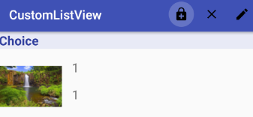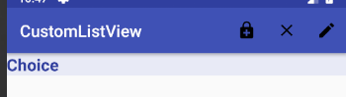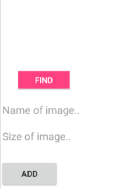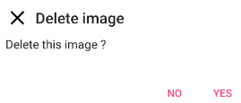

1. **Nhánh các thư mục**

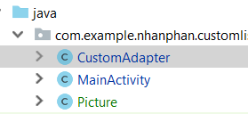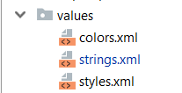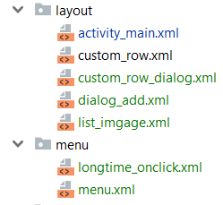

1. **Drawable**

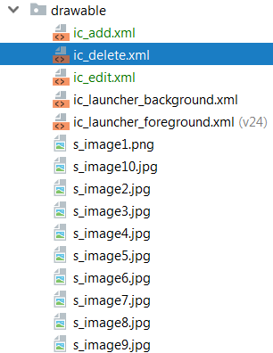

1. **Menu**

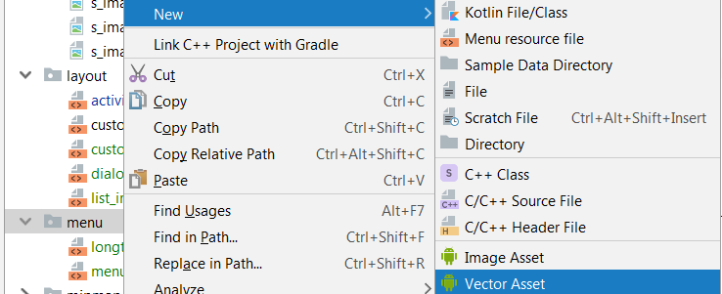 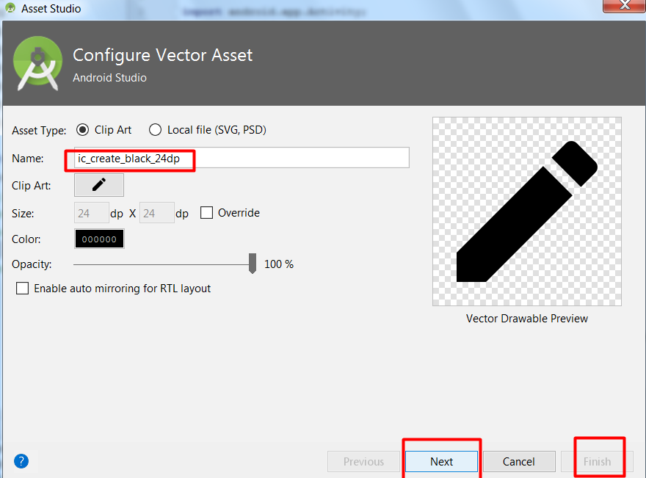

1. **longtime_onclick.xml**

* **Layout**

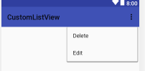 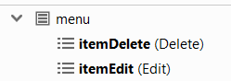

* **Code**

|  |
| --- |
| *<?***xml version="1.0" encoding="utf-8"***?>* <**menu xmlns:android="http://schemas.android.com/apk/res/android"**>  <**item  android:id="@+id/itemDelete"  android:icon="@drawable/ic_delete"  android:title="Delete"** />  <**item  android:id="@+id/itemEdit"  android:icon="@drawable/ic_edit"  android:title="Edit"** /> </**menu**> |

1. **menu.xml**

* **Layout**

 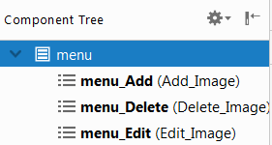

* **Code**

|  |
| --- |
| *<?***xml version="1.0" encoding="utf-8"***?>* <**menu xmlns:android="http://schemas.android.com/apk/res/android"  xmlns:app="http://schemas.android.com/apk/res-auto"**>  <**item  android:title="Add_Image"  android:id="@+id/menu_Add"  android:icon="@drawable/ic_add"  app:showAsAction="withText|always"** />  <**item  android:title="Delete_Image"  android:id="@+id/menu_Delete"  android:icon="@drawable/ic_delete"  app:showAsAction="withText|always"** />  <**item  android:title="Edit_Image"  android:id="@+id/menu_Edit"  android:icon="@drawable/ic_edit"  app:showAsAction="withText|always"** /> </**menu**> |

1. **String**

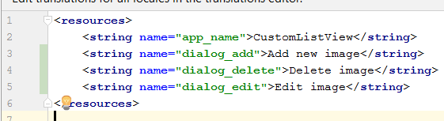

1. **Layout**
2. **activity_main.xml**

* **GUI**

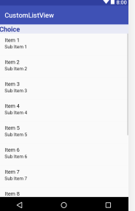 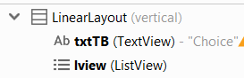

* **Code**

|  |
| --- |
| *<?***xml version="1.0" encoding="utf-8"***?>* <**LinearLayout xmlns:android="http://schemas.android.com/apk/res/android"  xmlns:app="http://schemas.android.com/apk/res-auto"  xmlns:tools="http://schemas.android.com/tools"  android:layout_width="match_parent"  android:layout_height="match_parent"  android:orientation="vertical"  tools:context=".MainActivity"  tools:layout_editor_absoluteY="81dp"**>  <**TextView  android:id="@+id/txtTB"  android:layout_width="match_parent"  android:layout_height="wrap_content"  android:text="Choice"  android:layout_gravity="center"  android:background="#E8EAF6"  android:textSize="20dp"  android:textStyle="bold"  android:textColor="@color/colorPrimaryDark"**/>  <**ListView  android:id="@+id/lview"  android:layout_width="match_parent"  android:layout_height="match_parent"** /> </**LinearLayout**> |

1. **custom_row.xml**

* **GUI**

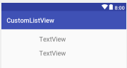 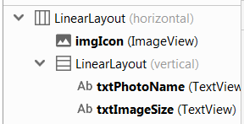

* **Code**

|  |
| --- |
| *<?***xml version="1.0" encoding="utf-8"***?>* <**LinearLayout  xmlns:android="http://schemas.android.com/apk/res/android" android:layout_width="match_parent"  android:layout_height="match_parent"  android:orientation="horizontal"**>  <**ImageView  android:layout_marginTop="10dp"  android:layout_width="100dp"  android:layout_height="100dp"  android:id="@+id/imgIcon"**/>  <**LinearLayout  android:layout_width="wrap_content"  android:layout_height="wrap_content"  android:layout_margin="16dp"  android:orientation="vertical"**>  <**TextView  android:id="@+id/txtPhotoName"  android:layout_width="wrap_content"  android:layout_height="wrap_content"  android:layout_weight="1"  android:textSize="20dp"  android:layout_marginBottom="16dp"  android:text="TextView"** />  <**TextView  android:id="@+id/txtImageSize"  android:layout_width="wrap_content"  android:layout_height="wrap_content"  android:layout_weight="1"  android:textSize="20dp"  android:text="TextView"** />  </**LinearLayout**> </**LinearLayout**> |

1. **custom_row_dialog.xml**

* **GUI**

 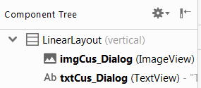

* **Code**

|  |
| --- |
| *<?***xml version="1.0" encoding="utf-8"***?>* <**LinearLayout  xmlns:android="http://schemas.android.com/apk/res/android" android:layout_width="match_parent"  android:layout_height="match_parent"  android:orientation="vertical"**>  <**ImageView  android:id="@+id/imgCus_Dialog"  android:layout_width="wrap_content"  android:layout_height="wrap_content"** />  <**TextView  android:id="@+id/txtCus_Dialog"  android:layout_width="wrap_content"  android:layout_height="wrap_content"  android:layout_gravity="center_vertical"  android:paddingLeft="10dp"  android:text="TextView"  android:textColor="#000"  android:textSize="20dp"** /> </**LinearLayout**> |

1. **dialog_add.xml**

* **GUI**

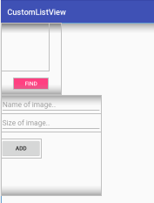 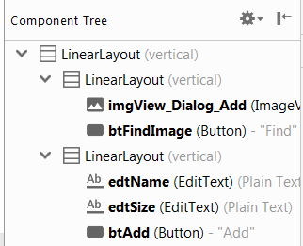

* **Code**

|  |
| --- |
| *<?***xml version="1.0" encoding="utf-8"***?>* <**LinearLayout  xmlns:android="http://schemas.android.com/apk/res/android" android:layout_width="match_parent"  xmlns:app="http://schemas.android.com/apk/res-auto"  android:layout_height="match_parent"  android:orientation="vertical"**>  <**LinearLayout  android:layout_width="150dp"  android:layout_height="180dp"  android:orientation="vertical"**>  <**ImageView  android:id="@+id/imgView_Dialog_Add"  android:layout_width="120dp"  android:layout_height="120dp"** />  <**Button  android:id="@+id/btFindImage"  android:layout_marginTop="16dp"  android:layout_width="wrap_content"  android:layout_height="30dp"  android:layout_gravity="center_horizontal"  android:text="Find"  android:textColor="#FFF"  android:background="@color/colorAccent"**/> </**LinearLayout**>  <**LinearLayout  android:layout_width="250dp"  android:layout_height="250dp"  android:orientation="vertical"**>  <**EditText  android:id="@+id/edtName"  android:layout_width="match_parent"  android:layout_height="wrap_content"  android:hint="Name of image.."  android:inputType="textPersonName"** />  <**EditText  android:id="@+id/edtSize"  android:layout_width="match_parent"  android:layout_height="wrap_content"  android:hint="Size of image.."  android:inputType="textPersonName"** />  <**Button  android:id="@+id/btAdd"  android:layout_width="100dp"  android:layout_height="wrap_content"  android:layout_marginTop="17dp"  android:text="Add"** />  </**LinearLayout**> </**LinearLayout**> |

1. **list_imgage.xml**

* **GUI**

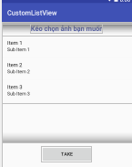 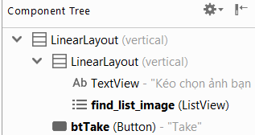

* Code

|  |
| --- |
| *<?***xml version="1.0" encoding="utf-8"***?>* <**LinearLayout  xmlns:android="http://schemas.android.com/apk/res/android"  android:layout_width="match_parent"  android:orientation="vertical"  android:layout_height="match_parent"**>  <**LinearLayout  android:layout_marginTop="5dp"  android:layout_width="wrap_content"  android:layout_height="350dp"  android:orientation="vertical"**>  <**TextView  android:layout_width="wrap_content"  android:layout_height="wrap_content"  android:text="Kéo chọn ảnh bạn muốn"  android:textSize="20dp"  android:textStyle="bold"  android:layout_gravity="center"  android:textColor="@color/colorPrimaryDark"**/>  <**ListView  android:id="@+id/find_list_image"  android:layout_width="500dp"  android:layout_height="200dp"  android:layout_marginTop="10dp"** />  </**LinearLayout**>  <**Button  android:id="@+id/btTake"  android:layout_gravity="center_horizontal"  android:layout_marginTop="10dp"  android:layout_width="150dp"  android:layout_height="wrap_content"  android:text="Take"** /> </**LinearLayout**> |

1. **Picture class**

|  |
| --- |
| **package** com.example.nhanphan.customlistview;  **public class** Picture {  **private int imgID**;  **private** String **imgName**;  **private** String **imgSize**;   **public** Picture(**int** imgID, String imgName, String imgSize) {  **this**.**imgID** = imgID;  **this**.**imgName** = imgName;  **this**.**imgSize** = imgSize;  }  **public** Picture(**int** imgID) {  **this**.**imgID** = imgID;  }  **public int** getImgID() {  **return imgID**;  }   **public void** setImgID(**int** imgID) {  **this**.**imgID** = imgID;  }   **public** String getImgName() {  **return imgName**;  }   **public void** setImgName(String imgName) {  **this**.**imgName** = imgName;  }   **public** String getImgSize() {  **return imgSize**;  }   **public void** setImgSize(String imgSize) {  **this**.**imgSize** = imgSize;  } } |

1. **CustomAapter class.**

|  |
| --- |
| **package** com.example.nhanphan.customlistview;  **import** android.app.Activity; **import** android.content.Context; **import** android.support.annotation.NonNull; **import** android.support.annotation.Nullable; **import** android.view.LayoutInflater; **import** android.view.View; **import** android.view.ViewGroup; **import** android.widget.ArrayAdapter; **import** android.widget.CursorAdapter; **import** android.widget.ImageView; **import** android.widget.TextView;  **import** java.util.ArrayList; **import** java.util.zip.Inflater;  **public class** CustomAdapter **extends** ArrayAdapter{  Context **context**;  *// Integer[] thumnails;  // String [] imageNames;* **private int resource**;  **private** ArrayList<Picture> **arr** = **new** ArrayList<Picture>();  **public** CustomAdapter( @NonNull Context context, **int** resource, ArrayList<Picture> arr){  **super**(context,resource,arr);  **this**.**context** = context;  **this**.**resource**= resource;  **this**.**arr** = arr;  }  @NonNull  @Override  **public** View getView(**int** position, @Nullable View convertView, @NonNull ViewGroup parent) {  *//return super.getView(position, convertView, parent);* LayoutInflater inflater = ((Activity)**context**).getLayoutInflater();  View row = inflater.inflate(**resource**, **null**);   **switch** (**resource**){  **case** R.layout.***custom_row***: *// resource kiểu int* ImageView imgIcon = (ImageView)row.findViewById(R.id.***imgIcon***);  TextView txtPhotoName = (TextView)row.findViewById(R.id.***txtPhotoName***);  TextView txtImageSize = (TextView)row.findViewById(R.id.***txtImageSize***);   Picture item = **arr**.get(position);  imgIcon.setImageResource(item.getImgID());  txtPhotoName.setText(item.getImgName());  txtImageSize.setText(item.getImgSize());  **break**;  **case** R.layout.***custom_row_dialog***:  ImageView imgDialog = row.findViewById(R.id.***imgCus_Dialog***);  TextView nameDialog = row.findViewById(R.id.***txtCus_Dialog***);  Picture itemDialog = **arr**.get(position);  imgDialog.setImageResource(itemDialog.getImgID());  nameDialog.setText(itemDialog.getImgID());  }  **return** (row);  } } |

1. **Code Main**

|  |
| --- |
| **package** com.example.nhanphan.customlistview;  **import** android.app.AlertDialog; **import** android.app.Dialog; **import** android.content.DialogInterface; **import** android.support.v7.app.AppCompatActivity; **import** android.os.Bundle; **import** android.view.ContextMenu; **import** android.view.Menu; **import** android.view.MenuItem; **import** android.view.View; **import** android.widget.AdapterView; **import** android.widget.Button; **import** android.widget.CursorAdapter; **import** android.widget.EditText; **import** android.widget.ImageView; **import** android.widget.ListView; **import** android.widget.TextView; **import** android.widget.Toast;  **import** java.util.ArrayList;  **public class** MainActivity **extends** AppCompatActivity {  String **imageNames**[] = {**"Jungle"**,**"image2"**,**"image3"**,**"image4"**,**"image5"**,**"image6"**,**"image7"**,**"image8"** ,**"image9"**,**"image10"**,};  Integer **img**[] = {R.drawable.***s_image1***,R.drawable.***s_image2***, R.drawable.***s_image3***, R.drawable.***s_image4***,R.drawable.***s_image5***,R.drawable.***s_image6***,R.drawable.***s_image7***,R.drawable.***s_image8***,R.drawable.***s_image9***,R.drawable.***s_image10***};   ListView **lv**;  TextView **txttb**;  **int pathImg**, **position**;  CustomAdapter **adapter**, **imagesAdapter**;*// adapter(main layout), imagesAdapter(ở Dialog)* ArrayList<Picture> **listImg** = **new** ArrayList<Picture>(); *//List hình ảnh main Layout* ArrayList<Picture> **arr_image** = **new** ArrayList<Picture>();*// List hình ảnh ở Dialog* **private void** loadAdapter(){  **adapter** = **new** CustomAdapter(**this**,R.layout.***custom_row***, **listImg**);  **lv**.setAdapter(**adapter**);  }  @Override  **protected void** onCreate(Bundle savedInstanceState) {  **super**.onCreate(savedInstanceState);  setContentView(R.layout.***activity_main***);   **lv** = (ListView) findViewById(R.id.***lview***);  **txttb** = (TextView) findViewById(R.id.***txtTB***);  loadAdapter();  registerForContextMenu(**lv**);  }  *//Tạo menu khi nhấn giữ một item trong listView* @Override  **public void** onCreateContextMenu(ContextMenu menu, View v,ContextMenu.ContextMenuInfo menuInfo) {  getMenuInflater().inflate(R.menu.***longtime_onclick***, menu);  **super**.onCreateContextMenu(menu, v, menuInfo);  }  @Override  **public boolean** onCreateOptionsMenu(Menu thisMenu) {  *//Tạo menu khi nhấn giữ một item trong listView* getMenuInflater().inflate(R.menu.***menu***, thisMenu);  **return super**.onCreateOptionsMenu(thisMenu);  }  *//Sự kiện thêm hình ảnh* **private void** Add(){  *//Dialog chứa hình ảnh* **final** Dialog imgDialog = **new** Dialog(**this**);  *//Dialog chứa thông tin cần nhập* **final** Dialog dialog = **new** Dialog(**this**);  dialog.setTitle(**"Add new image"**);  dialog.setContentView(R.layout.***dialog_add***);   **final** Button btFind = dialog.findViewById(R.id.***btFindImage***);  **final** Button btAdd = dialog.findViewById(R.id.***btAdd***);  **final** EditText name = dialog.findViewById(R.id.***edtName***);  **final** EditText size = dialog.findViewById(R.id.***edtSize***);  **final** ImageView pic = dialog.findViewById(R.id.***imgView_Dialog_Add***);   dialog.show();  *//Xử lí sự kiện nhấn nút Chọn hình ảnh(Find)* btFind.setOnClickListener(**new** View.OnClickListener() {  @Override  **public void** onClick(View view) {  imgDialog.setTitle(**"List pictures"**);  imgDialog.setContentView(R.layout.***list_imgage***);   **final** ListView listAllImages = imgDialog.findViewById(R.id.***find_list_image***);  **final** Button btTake = imgDialog.findViewById(R.id.***btTake***);   **for**(**int** i = 0; i < **img**.**length**; i++){ *// mảng ảnh* Picture a = **new** Picture(**img**[i]);  **arr_image**.add(a);  }  imgDialog.show();   listAllImages.setAdapter(**imagesAdapter**);   listAllImages.setOnItemClickListener(**new** AdapterView.OnItemClickListener() {  @Override  **public void** onItemClick(AdapterView<?> adapterView, View view, **int** i, **long** id) {   **pathImg** = **arr_image**.get(i).getImgID();  view.setBackgroundResource(R.color.***colorAccent***);  btTake.setOnClickListener(**new** View.OnClickListener() {  @Override  **public void** onClick(View view) {  pic.setImageResource(**pathImg**);  imgDialog.dismiss();  }  });  }  });  }*//Kết thúc chọn hình ảnh* });  *//Xử lí sự kiện khi nút Thêm (Add) được nhấn* btAdd.setOnClickListener(**new** View.OnClickListener() {  @Override  **public void** onClick(View view) {  **if**(**pathImg** == 0){  Toast.*makeText*(getApplicationContext(),**"Image is null.."**, Toast.***LENGTH_SHORT***).show();  }**else if**(name.getText().length() == 0){  Toast.*makeText*(getApplicationContext(),**"Name is null.."**, Toast.***LENGTH_SHORT***).show();  }**else if**(size.getText().length() == 0){  Toast.*makeText*(getApplicationContext(),**"Size is null.."**, Toast.***LENGTH_SHORT***).show();  }**else**{  **listImg**.add(**new** Picture(**pathImg**, name.getText().toString(), size.getText().toString()));  loadAdapter();  **pathImg** = 0; *//reset lại id của hình* dialog.dismiss();  Toast.*makeText*(getApplicationContext(),**"Add complete.."**, Toast.***LENGTH_SHORT***).show();  }  }  });  }  **private void** editImage(){  *//Dialog chứa hình ảnh* **final** Dialog imgDialog = **new** Dialog(**this**);  *//Dialog chứa thông tin cần nhập* **final** Dialog dialog = **new** Dialog(**this**);  dialog.setTitle(**"Edit image"**);  dialog.setContentView(R.layout.***dialog_add***);   **final** Button btFind = dialog.findViewById(R.id.***btFindImage***);  **final** Button btEdit = dialog.findViewById(R.id.***btAdd***);  **final** EditText name = dialog.findViewById(R.id.***edtName***);  **final** EditText size = dialog.findViewById(R.id.***edtSize***);  **final** ImageView pic = dialog.findViewById(R.id.***imgView_Dialog_Add***);   btEdit.setText(**"Edit"**); *//Sửa chữ Add thành Edit* dialog.show();  *//Xử lí sự kiện nhấn nút Chọn hình ảnh(Find)* btFind.setOnClickListener(**new** View.OnClickListener() {  @Override  **public void** onClick(View view) {  imgDialog.setTitle(**"List pictures"**);  imgDialog.setContentView(R.layout.***list_imgage***);*// lấy layout cho dialog* **final** ListView listAllImages = imgDialog.findViewById(R.id.***find_list_image***);  **final** Button btTake = imgDialog.findViewById(R.id.***btTake***);   *// Lấy hình ảnh vào ArrayList arr_iamge* **for**(**int** i = 0; i < **img**.**length**; i++){  Picture a = **new** Picture(**img**[i]);  **arr_image**.add(a);  }   imgDialog.show();   listAllImages.setAdapter(**imagesAdapter**);*// Đưa dữ liệu vào layout chứa danh sách hình ảnh* listAllImages.setOnItemClickListener(**new** AdapterView.OnItemClickListener() {  @Override  **public void** onItemClick(AdapterView<?> adapterView, View view, **int** i, **long** id) {   **pathImg** = **arr_image**.get(i).getImgID(); *// lấy id của hình* view.setBackgroundResource(R.color.***colorAccent***); *// background màu hồng mỗi lần click* btTake.setOnClickListener(**new** View.OnClickListener() {  @Override  **public void** onClick(View view) {  pic.setImageResource(**pathImg**); *//gán hình ảnh cho Dialog* imgDialog.dismiss();  }  });  }  });  }*//Kết thúc chọn hình ảnh* });  *//Xử lí sự kiện khi nút Thêm (Add) được nhấn* btEdit.setOnClickListener(**new** View.OnClickListener() {  @Override  **public void** onClick(View view) {  **if**(**pathImg** == 0){  **pathImg** = **listImg**.get(**position**).getImgID(); *//gán id hình cũ vào* }  **if**(name.getText().length() != 0){  **listImg**.get(**position**).setImgName(name.getText().toString()); *// gán tên mới vào nếu độ dài chuỗi nhập khác 0* }  **if**(size.getText().length() != 0){  **listImg**.get(**position**).setImgSize(size.getText().toString());*// gán size mới vào nếu độ dài chuỗi nhập khác 0* }  **listImg**.get(**position**).setImgID(**pathImg**); *// gán hình mới(hoặc cũ) vào* loadAdapter(); *// load lại dữ liệu* **pathImg** = 0; *//reset lại id của hình* dialog.dismiss(); *// đóng dialog* Toast.*makeText*(getApplicationContext(), **"Edit complete.."**, Toast.***LENGTH_SHORT***).show();  }  });  }  *//Xóa hình(Delete)* **private void** Delete(){  **final** AlertDialog.Builder builder = **new** AlertDialog.Builder(**this**);  builder.setTitle(**"Delete image"**)  .setIcon(R.drawable.***ic_delete***)  .setMessage(**"Delete this image ?"**)  .setNegativeButton(**"No"**, **new** DialogInterface.OnClickListener() {  @Override  **public void** onClick(DialogInterface dialogInterface, **int** i) {  }  })  .setPositiveButton(**"Yes"**, **new** DialogInterface.OnClickListener() {  @Override  **public void** onClick(DialogInterface dialogInterface, **int** i) {  **if**(**listImg**.size() == 0){  Toast.*makeText*(getApplicationContext(),**"The list is null.."**, Toast.***LENGTH_SHORT***).show();  }**else** {  **listImg**.remove(**position**);  loadAdapter();  Toast.*makeText*(getApplicationContext(), **"Delete complete.."**, Toast.***LENGTH_SHORT***).show();  }  }  });  builder.show();  }  @Override  **public boolean** onOptionsItemSelected(MenuItem item) {  **int** id = item.getItemId();  **switch** (id){  **case** R.id.***menu_Add***:  **imagesAdapter** = **new** CustomAdapter(**this**, R.layout.***custom_row_dialog***, **arr_image**);  Add();  **break**;  **case** R.id.***menu_Delete***:  **lv**.setOnItemClickListener(**new** AdapterView.OnItemClickListener() {  @Override  **public void** onItemClick(AdapterView<?> adapterView, View view, **int** i, **long** l) {  **position** = i;  }  });  Delete();  **break**;  **case** R.id.***menu_Edit***:  **if**(**listImg**.size() == 0){  Toast.*makeText*(getApplicationContext(),**"The list is null.."**, Toast.***LENGTH_SHORT***).show();  }**else** {  **lv**.setOnItemClickListener(**new** AdapterView.OnItemClickListener() {  @Override  **public void** onItemClick(AdapterView<?> adapterView, View view, **int** i, **long** l) {  **position** = i;  }  });  editImage();  }  **break**;  }  **return true**;  }  *//Xử lý sự kiện nhấn đè 1 item trong listView* @Override  **public boolean** onContextItemSelected(MenuItem item) {  *// Lấy thông tin về Context (view, item được chọn)* AdapterView.AdapterContextMenuInfo info = (AdapterView.AdapterContextMenuInfo) item.getMenuInfo();  **position** = info.**position**;  **int** id = item.getItemId();  **switch** (id){  **case** R.id.***itemDelete***:  Delete();  **break**;  **case** R.id.***itemEdit***:  editImage();  **break**;  }  **return true**;  } } |

1. **MENU**
2. **Demo App**

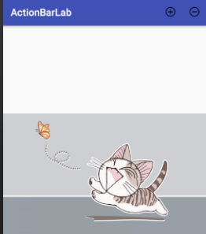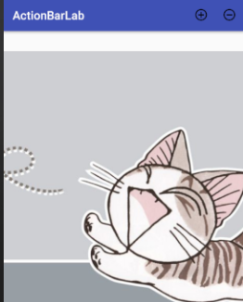

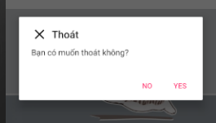

1. **Thư mục**

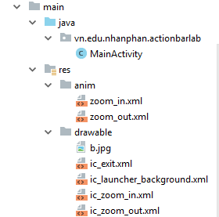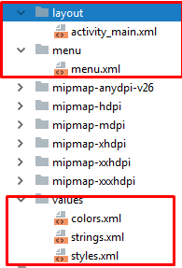

1. **Anim**

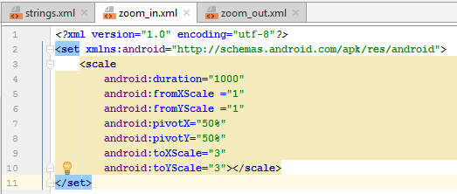

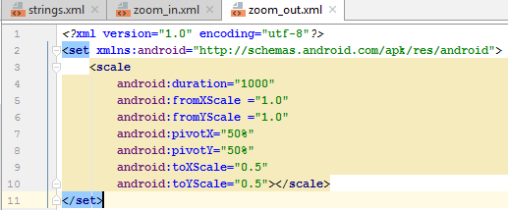

1. **Drawable**

Chọn ảnh, tạo thư mục,…

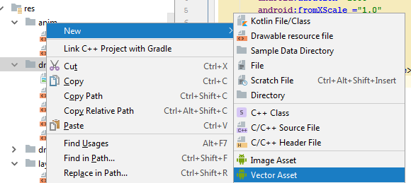

1. **Menu**

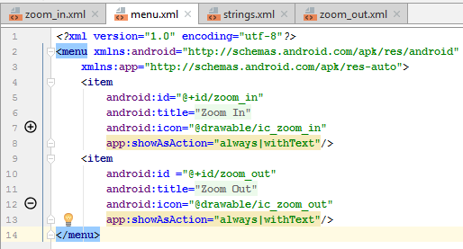

1. **Values**

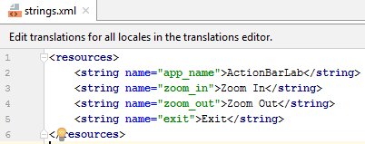

1. **Layout**

* **GUI**

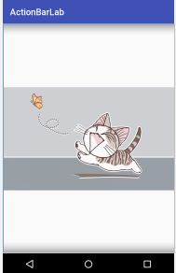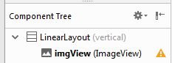

* **Code**

|  |
| --- |
| *<?***xml version="1.0" encoding="utf-8"***?>* <**LinearLayout xmlns:android="http://schemas.android.com/apk/res/android"  xmlns:app="http://schemas.android.com/apk/res-auto"  xmlns:tools="http://schemas.android.com/tools"  android:layout_width="match_parent"  android:layout_height="match_parent"  android:orientation="vertical"  tools:context=".MainActivity"**>  <**ImageView  android:id="@+id/imgView"  android:layout_width="match_parent"  android:layout_height="wrap_content"  app:srcCompat="@drawable/b"** /> </**LinearLayout**> |

1. **Code**

|  |
| --- |
| **package** vn.edu.nhanphan.actionbarlab;  **import** android.app.DatePickerDialog; **import** android.content.DialogInterface; **import** android.graphics.drawable.Animatable; **import** android.support.v7.app.AlertDialog; **import** android.support.v7.app.AppCompatActivity; **import** android.os.Bundle; **import** android.view.Menu; **import** android.view.MenuInflater; **import** android.view.MenuItem; **import** android.graphics.drawable.Animatable; **import** android.view.animation.Animation; **import** android.view.animation.AnimationUtils; **import** android.widget.ImageView;  **public class** MainActivity **extends** AppCompatActivity {  ImageView **imageView**;  @Override  **protected void** onCreate(Bundle savedInstanceState) {  **super**.onCreate(savedInstanceState);  setContentView(R.layout.***activity_main***);  **imageView** = (ImageView) findViewById(R.id.***imgView***);  }  @Override  **public boolean** onCreateOptionsMenu(Menu menu) { *// Lấy menu* MenuInflater inflater = getMenuInflater();  inflater.inflate(R.menu.***menu***,menu); *// Nhớ khai báo trong thư mục menu* **return true**;  *// return super.onCreateOptionsMenu(menu);* }  @Override  **public boolean** onOptionsItemSelected(MenuItem item) {  **int** id = item.getItemId();  Animation zoom = **null**;  **switch** (id){  **case** R.id.***zoom_in***:  zoom = AnimationUtils.*loadAnimation*(**this**, R.anim.***zoom_in***); *// Lấyt ừ thư mục* **break**;  **case** R.id.***zoom_out***:  zoom = AnimationUtils.*loadAnimation*(**this**, R.anim.***zoom_out***); *// Lấyt ừ thư mục* }  **imageView**.startAnimation(zoom);  **return super**.onOptionsItemSelected(item);  }   @Override  **public void** onBackPressed() {  AlertDialog.Builder builder = **new** AlertDialog.Builder(MainActivity.**this**);  builder.setTitle(**"Thoát"**)  .setMessage(**"Bạn có muốn thoát không?"**)  .setIcon(R.drawable.***ic_exit***).setPositiveButton(**"Yes"**, **new** DialogInterface.OnClickListener() {  @Override  **public void** onClick(DialogInterface dialog, **int** which) {  finish();  }  }).setNegativeButton(**"No"**, **new** DialogInterface.OnClickListener() {  @Override  **public void** onClick(DialogInterface dialog, **int** which) {  dialog.cancel();  }  }).create().show();  *//super.onBackPressed();* } } |

1. **GridView**
2. **DemoApp**

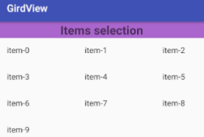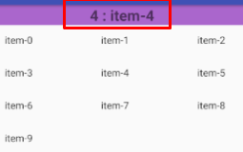

1. **Layout**
2. **String**

|  |
| --- |
| <**resources**>  <**string name="app_name"**>GirdView</**string**>  <**string-array name="data"**>  <**item**>item-0</**item**>  <**item**>item-1</**item**>  <**item**>item-2</**item**>  <**item**>item-3</**item**>  <**item**>item-4</**item**>  <**item**>item-5</**item**>  <**item**>item-6</**item**>  <**item**>item-7</**item**>  <**item**>item-8</**item**>  <**item**>item-9</**item**>  </**string-array**> </**resources**> |

1. **GUI**

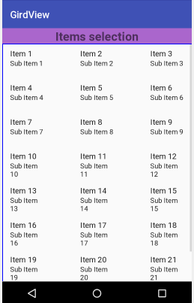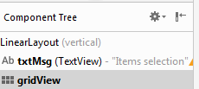

1. **Code**

|  |
| --- |
| *<?***xml version="1.0" encoding="utf-8"***?>* <**LinearLayout xmlns:android="http://schemas.android.com/apk/res/android"  xmlns:app="http://schemas.android.com/apk/res-auto"  xmlns:tools="http://schemas.android.com/tools"  android:layout_width="match_parent"  android:layout_height="match_parent"  android:orientation="vertical"  tools:context=".MainActivity"**>  <**TextView  android:id="@+id/txtMsg"  android:layout_width="match_parent"  android:layout_height="wrap_content"  android:background="@android:color/holo_purple"  android:textStyle="bold"  android:textSize="24dp"  android:gravity="center"  android:text="Items selection"** />  <**GridView  android:layout_width="match_parent"  android:layout_height="match_parent"  android:numColumns="auto_fit"  android:columnWidth="100dip"  android:stretchMode="spacingWidth"  android:verticalSpacing="5dip"  android:horizontalSpacing="5dip"  android:id="@+id/gridView"**/> </**LinearLayout**> |

1. **Code**

|  |
| --- |
| **package** vn.edu.nhanphan.girdview;  **import** android.support.v7.app.AppCompatActivity; **import** android.os.Bundle; **import** android.view.View; **import** android.widget.AdapterView; **import** android.widget.ArrayAdapter; **import** android.widget.GridView; **import** android.widget.TextView;  **public class** MainActivity **extends** AppCompatActivity {   TextView **textViewxtMsg**;  GridView **gridView1**;  @Override  **protected void** onCreate(Bundle savedInstanceState) {  **super**.onCreate(savedInstanceState);  setContentView(R.layout.***activity_main***);   **textViewxtMsg** = (TextView) findViewById(R.id.***txtMsg***);  **gridView1** = (GridView) findViewById(R.id.***gridView***);  ArrayAdapter a = ArrayAdapter.*createFromResource*(**this**, R.array.***data***,android.R.layout.***simple_list_item_1*** );  **gridView1**.setAdapter(a);  **gridView1**.setOnItemClickListener(**new** AdapterView.OnItemClickListener() {  @Override  **public void** onItemClick(AdapterView<?> parent, View view, **int** position, **long** id) {  TextView txtText = (TextView) view;  **textViewxtMsg**.setText(Integer.*toString*(position)+**" : "** + txtText.getText().toString());  }  });  } } |